Satero Ramos’ Round Robin Memorial

April 11-12
Proceeds from the tournament will go towards a College Scholarship in Satero’s name to a graduating HS Senior who participated in GYGSA’s League.

Official Tournament Packet for the Round Robin on April 11-12, 2026
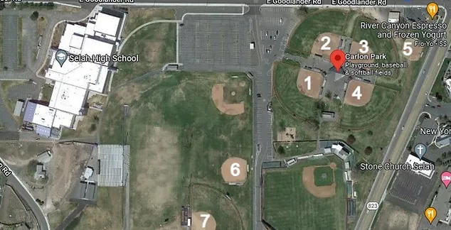
Please read through the specific rules and goals of this tournament. This packet is to help ensure that all the players and teams have a great time and get a lot of time on the fields.

Any questions or requests to make a change? Text or email Heather at 509-901-7911 ; gygsatourney@gmail.com

IF there are updates - I will post on the Event Info Tab on the USA site.

It includes:
- Map
- Link to USA Rule book
- GYGSA specific Rules
- Tournament Director and other Contacts
You are receiving this packet because you registered for this tournament.
However for your team to be eligible you also need:

- to be registered through USA Softball.

We will be utilizing fields 2, 3, 4, and 5. This is a 4gg tournament. Although due to the odd number of teams, some teams will have 5 games.
Note: Field 1 might be in use with our HS JV Fastpitch, however if the JV games are cancelled, all games scheduled for field 5 will move over to Field 1.

USA RULES for 2026 can be found here:

https://www.usasoftball.com/wp-content/uploads/sites/120/2023/12/2024_OfficialRulebook_USASoftball.pdf

Satero Ramos’ Round Robin Memorial Tournament Rules

Coaches may enter scores on the website for this
tournament. TD will verify scores entered with umpires.

Some 10u games might only have 1 umpire. We are short umpires for this weekend.

12u Rules USA Softball in effect, except as follows:
- All infielders are required to wear a facemask. Girls not wearing a mask should play in the outfield.
- Game Duration: No new inning 80 minutes.
- For the Round Robin- It is the coaches decision at the pregame meeting if they want to play with the 5 run mercy rule or not. Make sure the umpire knows what you decided. Same with run rules. This tournament is about getting reps in. Practice and having fun.
- All players that are in the game are batting (Round Robin Batting).
- Home team will be decided with a coin flip at the plate meeting before the game.

10U RULES USA Softball 10U rules in effect, except as follows.
1. 11” RIF-10 Ball.
2. All infielders need to wear a facemask.
3. Game duration:
No New Inning after 80 minutes
4. Round-robin batting must be used. Free defensive substitutions are allowed.
5. A maximum of five runs can be scored per inning by the team at bat. Play stops once the 5th run is scored (5 runs or 3 outs ends the inning).
6. 6 full innings or time limit, whichever comes first.
UPDATED INFO- Run Rules are to be decided at the plate meeting with the umpire.

Please remember, the goal of this tournament is for players to better understand the game and get more time on the field before your more competitive tournaments.
Have patience. Take time and give time for teachable moments.

PLAYER PLAY TIME and BASERUNNING All Divisions

Try not to bench a player for 2 consecutive innings except for injury, player request, or disciplinary reason.

2 bases maximum per pitch (runner can take an additional base, at their own risk). Unlimited after hit ball.
Examples: Base runners may proceed at their own risk to take a second base on an overthrow. Therefore, a player stealing second base, can advance to third on an overthrow, but would not be allowed to continue home on the same play (even if a subsequent overthrow occurs during the play). If a player is stealing third, she may take home on an overthrow to third. Batters that are walked or take 1st on a dropped strike, may continue to take 2nd at their own risk, but could not then take third on an overthrow. This remains consistent with the statement that players can take 2 bases maximum per pitch. This rule does not apply to base running after a hit ball. Base runners are not limited to the number of bases they can take on overthrows that occur after a hit ball except when the ball is thrown out of play. In this case, the standard bases are awarded for the ball out of play.

Suggestion: Coaches are encouraged to finish the play in order to teach girls the proper way to play the game and increase their understanding, then allow the umpires to place the girls back at the appropriate base following the completion of the play.

ASA/USA Softball points of emphasis
11” RIF-10 ball, 35’ pitching distance.( 10u )
Home team must provide official scorekeeper.
Home Team is decided with a coin flip at the start of the game.
Infield fly rule is in effect.
Dropped 3rd strike per USA rules.
Open home plate. Must avoid collision per USA rules
No more than 6 (six) players may be positioned in front of the base paths.
Outfielders must remain in the grass (or at least10 feet behind the bases) until the ball is hit or a play is made on a base path.
No more than 9 (nine) players may play defense at one time.

IMPORTANT INFORMATION

- Coaches need to check-in with me at least an hour before their first game.
- USA ROSTERS need to be updated and include pick-up players on the USA Softball (Register Play) site 24 hours before game time.
- ALL players will receive a 2026 Satero Ramos’ Patch for playing in this fun Round Robin

CONTACTS
Tournament Director- Heather Lee
Text or Call- 509-901-7911
gygsatourney@gmail.org
T-Shirt Sales and Logo Design-
Designs Northwest Nicole Miles
Designsnorthwest1@gmail.com
Payment Issues Contact
GYGSA President & Treasurer Coreena Holden
gygsapresident@gmail.com

