
6U State Tournament

June 5, 2026-June 7,2026


Hosted by : USA SOFTBALL of Texas District 43

Host Fields: Rose Rich Girls Softball Association

George Park
2115 Collins Rd, Richmond TX 77469

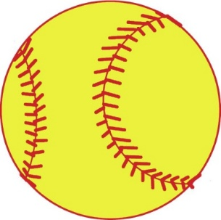

Tournament Details
- Date: June 5 - June 7, 2026
- Site: George Park, 2155 Collins Rd, Richmond, TX 77469
- Format: Two pool play, Double Elimination
- Entry Fee: $275.00 per team (league checks only or money order-payable to Texas ASA D 43)
- Register on TournamentUSAsoftball.com
- Mail entry fee to: Texas ASA/District 43, 126 5th Street, Sugar Land, TX 77498
- Umpire PAP: $50 (pool play), $50 (bracket) per team, paid in cash
- Entry Deadline: May 31, 2026
- Gate Fee: $15/day or $20/weekend
- No outside food or drink. One team cooler per team allowed.
- Tournament Draw: June 3, 2026 by 10pm- will be posted on Tournament website

Roster and Certification Requirements
- All rosters must be completed and signed by the District Commissioner.
- A copy of each player's birth certificate and USA SOFTBALL ID card with photo (if available) must accompany the roster.
- All coaches must have Background check, SafeSport certification.

Meetings and Location
- Managers Meeting: Friday, June 5, 2026 at 12 PM
- Location: SpringHill Suites, 6815 Reading Rd, Rosenberg, TX 77471
- Teams must have a representative present; limit to 2 reps per team due to limited space.

Tournament Rules
- Games will be played by the 2026 USA Softball Pixie Championship Playing Rules.
- Game balls will be furnished by the tournament.
- Uniforms must conform to the 2026 USA Softball Code.
- Time limits: 50 minutes for pool games, 55 minutes for bracket games, and the championship game will be 55 minutes or 6 innings.
- Tie breaker rules follow the 2026 USA Softball Code.
- First games begin June 5, 2026 at 5 PM. Be prepared for possible earlier start times depending on the number of registered teams.

Awards
- Awards: 1st, 2nd, and 3rd place
- Tournament shirts: Pre-order forms available; shirts will also be sold on site.

Tournament Directors and Contacts
- Tournament Directors: Mike Rychlik, Jennifer Torres
- District Commissioner: JO Commissioner
- Contact numbers: 281-455-7683, 832-752-2108
- Rodney Smith, Jennifer De Leon - District UIC and Deputy JO Commissioner
- Email: usasoftballtxd43@gmail.com

Tournament General Information Sheet

- Tournament will be two pool, double elimination with all play being governed by the 2026 USA Softball Texas championship rules.

- The tournament host will furnish the game balls.

- Teams must be ready to play day or night. Game time is forfeit time.

- All teams must be ready to play at 5:00 pm on Friday, June 5, 2026

- All games will be 55 minute pool games, 55 minute bracket games, Championship game 55 Minute time limit or 6 innings.

- Run rule will be in effect for all games. 15 runs after 3 innings, 12 runs after 4 innings, or 8 runs after 5 innings.

- Protests must be registered with the plate umpire before the next pitch. The protest committee will render a ruling before play resumes. No protests will be accepted on umpire’s judgment.

- NO infield practice will be allowed at anytime on the game fields.

- Home team will be decided by a coin flip. Team manager/coach will meet a tournament representative/scorekeeper at a designated area behind the backstop outside field 30 minutes prior to game time. This will enable the teams to proceed to the correct dugout.

- All teams must be ready to play and at field at least 15 mins prior to game start.

- Alcohol or smoking is not permitted in any area of the complex.

- The tournament director reserves the right to switch teams to a different field for the purpose of saving time when behind schedule or for other circumstances that may occur.

- A suspended game will be resumed from the point of suspension.

- All coaches/players must have USA Softball of Texas Player Registration card/proper ID present at all time

USA SOFTBALL OF TEXAS
DISTRICT 43
6U ALLSTARS STATE TOURNAMENT
T-SHIRT PRE-ORDER FORM
MVP SCREEN PRINT
100 Cypresswood Drive Spring, TX 77388
For all Preorders Call: (346) 733-2319 Email: zapata051154@GMAIL.COM

TEAM NAME: __________________________________
MANAGER: _________________________________

ADDRESS: _______________________________ CITY: _________________ STATE: ____
ZIP: __________

PHONE NUMBER: _______________________
EMAIL: ___________________________________________

NAME OF PERSON PICKING UP SHIRTS AT PARK: __________________________________________________

ONLY PRE-ORDER SHIRTS WILL BE AT A DISCOUNT SO PLEASE TAKE ADVANTAGE OF THIS PRICE. ONCE WE ARE AT THE PARK THE DISTRICT TOURNAMENT SHIRTS WILL BE SOLD FOR $25.00. THE LARGER SIZES WILL BE AVAILABLE ON PRE-ORDER ONLY. AT STATE TOURNAMENT, WE WILL ONLY HAVE YOUTH SMALL – ADULT XL ONLY. WE ACCEPT CREDIT CARDS, CASH/DEBIT AND TEAM OR ORGANIZATION CHECKS ONLY. NO PERSONAL CHECKS. THERE IS A FEE OF $1.00 PER EVERY $50.00 SO YOU CAN CALL IT IN AND WE WILL SEND YOU A RECEIPT ON YOUR PHONE. IF THE CHECK IS RETURNED, THERE IS A $35.00 BANK FEE AND YOU MUST PAY IN CASH AT TIME OF PICKUP.
PLEASE MAKE SURE YOU ORDER BEFORE THE DEADLINE! JUNE 4 2026
MAKE CHECKS PAYABLE TO: DAVID PADILLA (owner)
IF YOU HAVE QUESTIONS OR CONCERNS, PLEASE FEEL FREE TO CALL OR EMAIL.

YOUTH SMALL – YOUTH XLARGE : ADULT SMALL – ADULT XLARGE -- $20.00 ADULT 2X – 3X – 4X – 5X WILL BE $22.00

YOUTH SMALL –_____________________ ADULT SMALL: __________________

YOUTH MEDIUM: ____________________ ADULT MEDIUM: _________________

YOUTH LARGE: ______________________ ADULT LARGE: ___________________

YOUTH XLARGE : ____________________ ADULT XLARGE -- $25.00___________

2X______ 3X_______ 4X______ 5X_______

TOTAL AMOUNT $_________________________

CK# _________________ CC_______________________

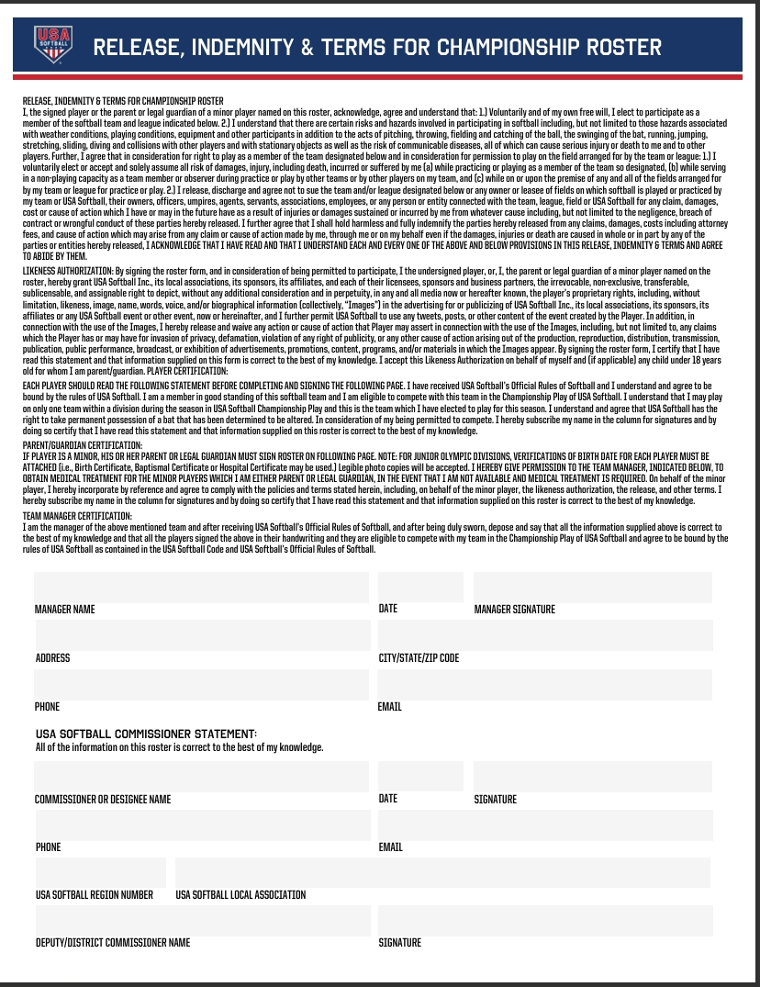

Local Hotels

Host Hotel-
SpringHill Suites by Marriott Houston Rosenberg
- 6815 Reading Rd, Rosenberg, TX 77471- 832-595-2220
for 90.00 USD - 100.00 USD per night - Last Day to Book : Monday, May 25, 2026
Book your group rate for 6U State Tournament 2026
Start Date: Friday, June 05, 2026 End Date: Sunday, June 07, 2026

Hampton Inn & Suites – Queen Rooms (2 beds)- 131.00 +tax
3312 Vista Drive, Rosenberg TX 77471
281-341-9393

Holiday Inn Express- Standard Double (2 beds)- $119.00+tax
Group Name: 6 and under State Championship
1720 Spacek Rd, Rosenberg TX 77471
346-843-1777

